MSDS680_S40_ Machine Learning
Week 8 capstone project
Ilse Severance
2026
Week 8 Capstone Project: Executive Summary – Predicting Loan Default
- Problem and Solution Overview
Problem: The bank wants to reduce financial risk by identifying borrowers who are most likely to default on loans.
Solution: We built a machine learning model using historical loan data to assess each borrower’s likelihood of default. The model assigns a risk score prediction, allowing loan officers and analysts to prioritize reviews and manage portfolio risk effectively.
- Key Findings
- Only a small fraction of borrowers (about 12%) default, so most loans are safe.
- Borrowers with high loan amounts relative to their income, higher interest rates, and moderate credit scores are most likely to default.
- Engineered risk measures like Loan-to-Income Ratio and Credit-DTI Risk provide strong insight into borrower risk.
- The model is very good at ranking borrowers by risk, it rarely flags safe borrowers incorrectly, but it misses some actual defaults under the current threshold.
- Simple features like age and income still contribute meaningfully to risk assessment.

- Model Performance
The model is effective at highlighting the riskiest borrowers. While it does not catch every potential default, it allows the bank to focus attention on the highest-risk segment of applications and portfolio loans. In other words, it’s better at prioritizing risk than predicting every default, which aligns with operational needs.
- Recommended Actions

  - Prioritize High-Risk Borrowers: Use the model’s risk scores to flag borrowers with the highest likelihood of default for deeper review or additional documentation.
  - Enhance Credit Guidelines: Incorporate insights from key risk factors (Loan-to-Income Ratio, Credit-DTI Risk, Interest Rate) into lending policies to reduce exposure to risky loans.
  - Tailor Loan Terms: Consider adjusting interest rates, repayment plans, or collateral requirements for high-risk applicants based on their predicted risk score.
  - Monitor Portfolio Risk Continuously: Regularly track the predicted risk distribution across the loan portfolio to detect shifts in borrower behavior early.
  - Educate Loan Officers and Analysts: Provide training on interpreting risk scores and risk factor contributions, so decisions are supported by data insights rather than intuition alone.
  - Plan for Future Data Enhancements: Begin collecting additional borrower information (e.g., credit history trends, employment stability, prior delinquencies) to improve predictive power over time

- Top Risk Factors
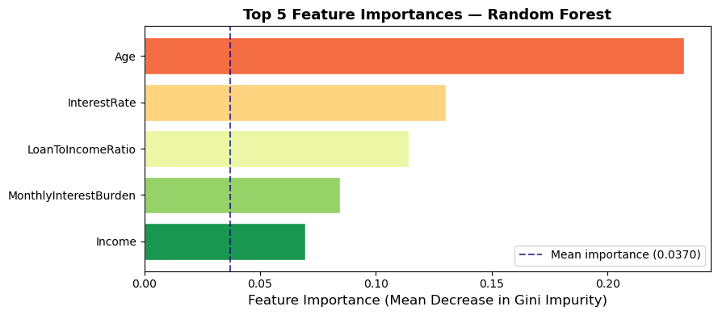
This analysis identifies the top 5 factors most strongly associated with borrower default risk, enabling loan officers and analysts to prioritize the highest risk accounts and make data driven lending decisions. By linking the visualization directly to actionable insights, stakeholders can quickly see which factors matter most without needing to interpret technical metrics like ROC-AUC or F1-score. Enhancements such as annotations or color coding to show whether higher values increase or decrease default risk make the chart even more intuitive, helping guide reviews, adjust loan terms, and refine credit policies.

